Simple OS Simulator, Phase 2: Paging



Nicolas Perez
Suat Iskender
Department of Computer Science
Kennesaw State University
11/29/2016

Contents

Using the Simulator 3
Architecture Block Diagram 4
Overview of Modifications 4
Additional Improvements 5
The Paging System 6
The Page Table 6
The CPU and Page Fault Detection 6
The Page Manager 7
The Free Frame Pool 7
The FrameFreer 8
Handling IO – the DMA thread 8
Synchronization Overview 9
Thread Synchronization Diagram 10
Scheduling Algorithm Implementation 11
Design Approach & Difficulties 12
Metrics & Results 13
Methodology 13
Progress of the Job Queues Over Time 14
Memory Usage 15
Tracking the Number of Free Frames 16
Number of Page Faults and Fault Service Time 17
Increasing the Page size 17
Effects of Increasing the Page Size 18
Effects of Varying the Number of CPUs 19
Scheduling Algorithm Performance 20
Comparison with Phase 1a and Phase 1b 21
Conclusions 22
Appendix A: QueueWatch 23
QueueWatch FIFO 23
QueueWatch Priority 30
QueueWatch SJF 37
QueueWatch FIFO with Slow Disk 44
Appendix B: Results From Changing the Page Size 53
timingFIFO (pagesize 4) 53
timingFIFO pagesize8 54
timingFIFO pagesize16 55
Appendix C: Results of Varying the Number of CPUs 57
Timing – 1 cpu FIFO 57
Timing – 2 cpus FIFO 58
Timing – 8 cpus FIFO 59
Timing – 16 cpus FIFO 60
Appendix D: Scheduling Algorithm Results 61
Timing – SJF 61
Timing – FIFO 62
Timing – Priority 63

Using the Simulator

Type java -jar osproj1.jar to run the simulator from a console window.
ProgramFile.txt should be in the same directory.
At the prompt, the user may choose to enable logging, or to run the simulator for multiple iterations.

Note: error-checking can be turned on by setting
CHECK_OUTPUT_MODE = true
from within the driver file. If it is on, it compares the simulator output to the CorrectOutput.txt file. Currently, error checking is off.

The following output file is generated:

timing.csv Waiting Time, Completion Time, and Run Time for each job.

queuewatch.csv Size of Ready, Waiting, Done and Free Frames queues after each iteration of the scheduler.

diskdump.txt Contents of the disk after simulator finishes executing all the jobs.

If logging is enabled, the following additional output files are generated:
output.txt number of IO operations, and Input, Temp and Output buffers for each job.

Architecture Block Diagram
Long-Term Scheduler
Short-Term Scheduler/Dispatcher
Page Manager

Driver Post-Processing (output, timing data)
Disk (512 pages)
Memory (256 pages)
Program File
Loader
Driver
PCB Queues
DiskQueue
ReadyQueue
RunningQueues[4]
WaitingQueue
IOWaitQueue
DoneQueue

End
Frame Freer

CPU

CPU

CPU

CPU
Page Fault
Main loop

DMA
Cache
Cache
Cache
Cache
IO

IO

IO

Overview of Modifications

First, a brief overview of the primary modifications for Phase 2:

- The disk, memory, and CPU caches are now paged.
- Each job has a page table to track its pages in memory.
- The page manager services page faults, loading requested pages into free frames of memory, from the free frame pool.
- Processes may be suspended on the waiting queue, allowing the CPUs to run other jobs.
- IO to memory is handled by the DMA thread, and while this occurs the process is suspended on the IO Wait Queue.
- Upon process completion, the frame freer saves the contents of the process’s memory space to disk, before re-adding them to the free frame pool.

Additional Improvements
Here are some additional changed implemented with Phase 2.

- After each iteration, the simulator’s output is checked for accuracy, relative to the “CorrectOutput.txt” file.
- Communication between threads has been streamlined and simplified, through the use of java blocking queues.

The Paging System

Disk, memory, and CPU caches are now paged into page/frame sizes of 4 words. A cache size of 20 pages was chosen – large enough to hold the largest job in its entirety, without page replacement.

memArray = new int [256][4];
diskArray = new int[512][4];
cache = new int[20][4];

The Page Table
Each job has its own page table, stored in the PCB. For simplicity, the page table mirrors the cache with size 20.

pageTable = new int[20][3];

Each of the 20 entries in the page table holds 3 values (implemented here as a 20x3 array).

- location: the location of the page in physical memory.
- valid/invalid: A page fault occurs when a process attempts to reference a page marked invalid. This means that the requested page must be loaded into memory.
- modified: If a page table entry is marked modified, it will need to be written back to disk, before its frames can be deallocated.

The CPU and Page Fault Detection

Page faults can happen one of two ways:

- The CPU tries to fetch an instruction that has not yet been loaded into memory.
- The CPU tries to execute an IO instruction that reads or writes to a page not yet loaded into memory.

In our implementation, page fault detection occurs in the CPU. To do this, both fetch and execute now return a variable of type CacheResult, with the valid field indicating if a page fault has occurred.

class CacheResult {
boolean valid; //set to false in event of a page fault.
int page;
int offset;
int data;
}

Upon page fault, the CPU suspends operation, saves the context information, and transfers the job being run into the Waiting Queue. The scheduler can then assign the CPU to run another job from the Ready Queue.

The Page Manager

The Page Manager thread services page faults, loading the requested pages into memory.

- The Page Manager takes a job from the Waiting Queue. If no jobs are on the Queue, it waits for one.
- The Page Manager takes a free frame from the free frame pool. If no frames are currently available, it waits for one.
- It loads the page requested from disk, into the free frame. The page request is stored in the PCB.
- The page’s entry in the job’s page table is updated with the physical address, and the valid bit is set.
- The job is placed back into the Ready Queue, ready to be assigned to the next available CPU.

The Free Frame Pool

Processes are allocated memory from the free frame pool. This is a list with 256 entries initially, one for each frame of physical memory.

freeFrameList = new LinkedBlockingQueue();
for (int i = 0; i < 256; i++)
freeFrameList.put(i);

Each of the 30 processes is initially assigned 4 memory frames to begin with. This leaves 136 (256-30x4) free frames, before the CPUs start running the jobs.

The FrameFreer

After each process is complete, its frames are deallocated by the Frame Freer thread.

- Upon job completion, the CPU adds the job to the Free Frame Request Queue (FFRQ).
- The Frame Freer takes a job from the FFRQ. If no jobs are on the Queue, it waits for one.
- The Frame Freer checks the Modified column for each entry in the job’s page table. If a page is marked Modified, it is written back to disk.
- The completed job’s frames are zeroed out, and added back to the Free Frame Pool.
- The entries in the job’s page table are marked invalid.

Handling IO – the DMA thread

As a job executes, the CPU cache is modified. The modifications must be written from the cache back to memory, before the CPU can load another job. In our implementation, this task is handled by the DMA thread.

The DMA thread waits for a job to be loaded onto the ioWaitQueue, processes the IO request, and then hands control back to the CPU which called it.
Synchronization Overview

There are multiple CPU threads, a driver/scheduler thread, a page manager thread, a DMA thread, and a frame freer thread. Here is an overview of how these threads work together. A diagram to illustrate this process can be found on the next page.

Driver/Short-term Scheduler/Dispatcher:
- Take a job from the Ready Queue, or wait if none are available.
- Take a CPU from the Free CPU Queue, or wait if none are available.
- Assign the job to the CPU’s Running Queue.
- Return to step 1, repeat until a CPU signals that all jobs are complete.
- If all jobs are complete, signal the other threads to shut down.

CPU(s):
- Take a job from the CPU’s Running Queue, or waits if a job is not available.
- Execute the job until it completes, or a page fault occurs (non-preemptive execution).
- If the cache was modified, add job to the IO Wait Queue, and wait for IO to complete.
- If page fault: save context information, add job to the Waiting Queue, and return to step 1. Repeat.
- If job complete: Add job to the Free Frame Request Queue. Return to step 1, repeat.
- If all jobs are complete, signal the Driver/Scheduler to stop.

Page Manager:
- Take a job from the Waiting Queue, or wait if none are available.
- Take a free frame from the Free Frame List, or wait if none are available.
- Service the page fault. Return to Step 1 and repeat.

Frame Freer:
- Take a job from the Free Frame Request Queue, or wait if none are available.
- Copy modified pages back to disk as necessary.
- Add the frames to the Free Frame List. Return to Step 1 and repeat.

DMA Thread:
- Take a job from the IO Wait Queue, or wait if none are available.
- Save modified cache back to memory.
- Signal the CPU calling it that IO is done.
- Return to Step 1 and repeat.

Thread Synchronization Diagram

Job interrupted or completed
Page Manager

Free CPU Queue
Ready Queue
Waiting Queue
CPU #0
CPU #1
CPU #2
CPU #3
Running Queue[0]
Running Queue[1]
Running Queue[2]
Running Queue[3]
Frame
Freer

Free Frame Queue
On Page Fault
Job Done

Driver-
STS-
Dispatcher
Frames Deallocated

Free Frame Pool

Io Wait Queue
Io Done Queue

Page Fault Serviced (Page Loaded into Memory)

Key:
Arrows = Queues.
Rectangles = Threads.
DMA
Scheduling Algorithm Implementation

The Ready Queue and Waiting Queue are now implemented as Priority Blocking Queues. This made implementation of the scheduling algorithms incredibly simple. By adding a few lines of code, jobs are automatically added to the Ready Queue or Waiting Queue according to the order of job arrival (FIFO scheduling), by job priority (Priority scheduling), or by job size (SJF scheduling).

Comparator<PCB> comparatorPCB;
switch (policy) {
case (PRIORITY):
comparatorPCB = (PCB o1, PCB o2)-> o2.priority - o1.priority;
case (SJF):
comparatorPCB = (PCB o1, PCB o2) -> o1.jobSizeInMemory –
o2.jobSizeInMemory;
case (FIFO):
comparatorPCB = (PCB o1, PCB o2) -> o1.order - o2.order;
}
readyQueue = new PriorityBlockingQueue<PCB>(NUM_JOBS, comparatorPCB);
waitingQueue = new PriorityBlockingQueue<PCB>(NUM_JOBS, comparatorPCB);

As noted in the Synchronization Overview, our scheduling algorithm implementation is non-preemptive: processes run until completion, page fault or IO request. We do not allow processes to interrupt other processes that are currently running.

Design Approach & Difficulties

For phase 2, the hardest part was getting all the threads to work together, and to handle race conditions. At first, there was a lot of headache-inducing synchronization code, with a profusion of locks, and waits, and notifys, that would nonetheless still freeze and generate errors due to race conditions.

But once we got the hang of java blocking queues, everything fell into place. Converting the ready queue and waiting queue into PriorityBlockingQueues made the code cleaner and simpler. We are not aware of any bugs or race conditions in the program!

One regret we have is that the finished product is very different from an actual operating system (unless we are talking about an operating system made by Microsoft). For example, rather than having one centralized memory subsystem, our implementation has multiple modules (Page Manager, Frame Freer, DMA) that can access and modify memory at once. This is probably not very realistic given hardware constraints. On the other hand, we took advantage of the formidable tools in Java available to us, and made it work.

In retrospect, it would also have been extremely helpful to create a GUI front-end for the program, such as one John demonstrated in class. There were so many variables to manipulate and so much data to gather by the end of Phase 2, that collecting the data became a major task in and of itself.

Metrics & Results

Methodology

The methods to compile and output timing data are located in the Timing.java module.

In phase 1, we used
System.currentTimeMillis () was used to track the time, which was then stored in the job’s PCB.

Wait Time: the time a job spends waiting, and not executing. (Note: we defined Wait Time to include the Page Fault Service Time, the logic being that while the page fault is being serviced, the process is “waiting around” and not executing.)

Wait Time was used as the primary metric for performance, as it was by far the largest component of job completion time.

Completion Time: the time it takes to finish a job after it is put in the Ready Queue.

Execution Time: the actual time spent by the CPU executing the code.
Note: execution time was minimal, between 0-1 ms total.

Page Fault Service Time: the time spent by the Page Manager servicing the page fault, and loading a job’s page into memory.

IO Time: time taken by the DMA thread to conduct IO, moving data from the cache to memory.

In the real world, memory access and especially disk access are the cause of major performance bottlenecks. To simulate this, we included adjustable delays for disk and memory access at the start of the CPU class.

Progress of the Job Queues Over Time

Below is a graph tracking the progress of the jobs through the simulator, over time. Initially, 30 jobs are loaded onto the Ready Queue. As they are run, they are added to the Running Queues. As these jobs run and begin page faulting, they are added to the Waiting Queue – waiting for the page faults to be serviced. Finally, as the jobs complete, they are added to the Done Queue.

(Note: the snapshots are taken just before a job is loaded by the Scheduler onto the CPU. Hence, the graph underestimates the number of jobs running at a given time.)

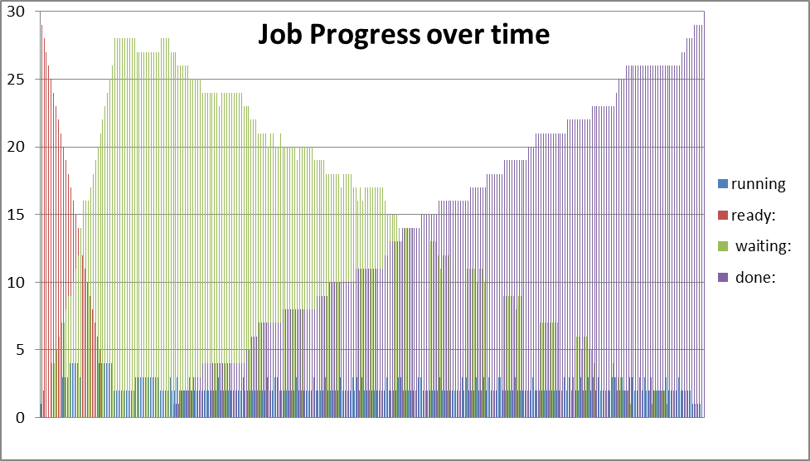

The raw data for this is from the QueuewatchFIFO file and is included in Appendix A.

Memory Usage

In Phase 1, jobs were loaded into memory in their entirety. But in Phase 2, only the first four frames of a job were initially loaded, with the rest of the job being loaded as needed.

Consequently, we found that Phase 2 used much less memory than Phase 1, despite loading all 30 jobs into memory at once.
Max Memory Usage, Phase 1 vs Phase 2 default settings
 | # Frames Used | Max Mem Usage
FIFO | 145 | 57%
Priority | 135 | 53%
SJF | 135 | 53%
Phase 1 FIFO | --- | 99%
Phase 1 Priority | --- | 99%
Phase 1 SJF | --- | 96%

With the default settings, we found that our Phase 2 implementation only used about half of the available memory, as compared to Phase 1, which used over 99% of available memory.

The raw data for this was compiled from the QueuewatchFIFO, QueuewatchPriority and QueuewatchSJF files and is included in Appendix A.

Tracking the Number of Free Frames

Below is a graph tracking the number of free frames, over time, for the FIFO scheduling algorithm. As noted earlier, we start with 136 free frames (256-30x4 assigned at the start). As the jobs page fault, frames are loaded into memory, and the number of free frames decreases. As jobs complete, their frames are deallocated, and the number of free frames rises.

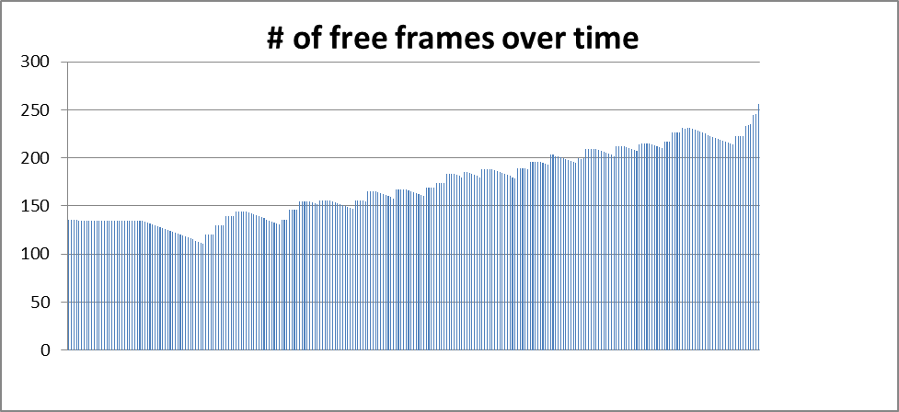

Suppose however that we have an extremely slow disk. We can simulate this by setting
int DISK_ACCESS_DELAY = 10000000;

Now the frame freer process is extremely slow to deallocate frames, and the CPUs must wait for free frames to become available. This behavior can be seen in the below graph.
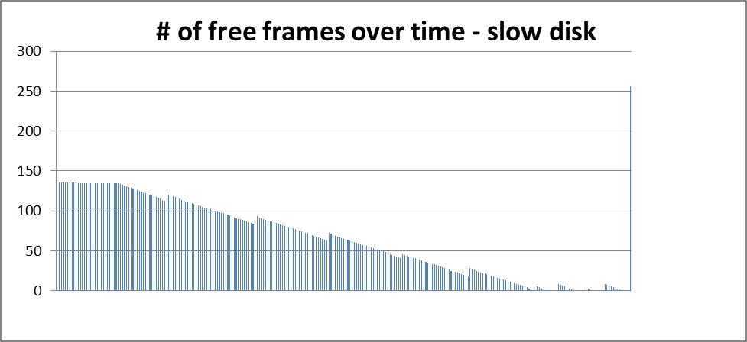

The data is from the QueuewatchwithSlowDisk file and is included in Appendix A.
Number of Page Faults and Fault Service Time

We recorded a total of 242 page faults, for a page size of 4 words.

Fault service time was <= 10 milliseconds/page fault.

On average, this was approximately 8 page faults / job.

However, we can vary this by changing the page size.

Increasing the Page size

Increasing the page size was a bit more complex than simply changing a single setting in the simulator.
First, we change the PAGE_SIZE constant.

static public final int PAGE_SIZE = 8;

But if we increase the page size, we must also increase the disk size. Due to internal fragmentation with larger page sizes, the 30 jobs no longer fit onto a disk of 2048 words!

public static final int DISK_SIZE = 2400/MemorySystem.PAGE_SIZE;

Finally, we must modify the number of frames loaded into memory by the long term scheduler. With a page size of 8, we have 128 frames of memory total. If we assign 120 of them at the start, that only leaves 8 free frames of memory at the start! Because there isn’t enough memory to complete any program, in this situation, our simulator hangs. So, to avoid this, we set

final static int NUM_FRAMES_TO_LOAD = 2;

in the long term scheduler, and now we can run the simulator with the desired larger page size.

Effects of Increasing the Page Size

Increasing the page size caused the number of page faults to decrease, and performance to increase substantially, as the below graphs show. The raw data for this was compiled from the timingFIFO, timingFIFO pagesize8 and timingFIFO pagesize16 files, and is included as Appendix B.

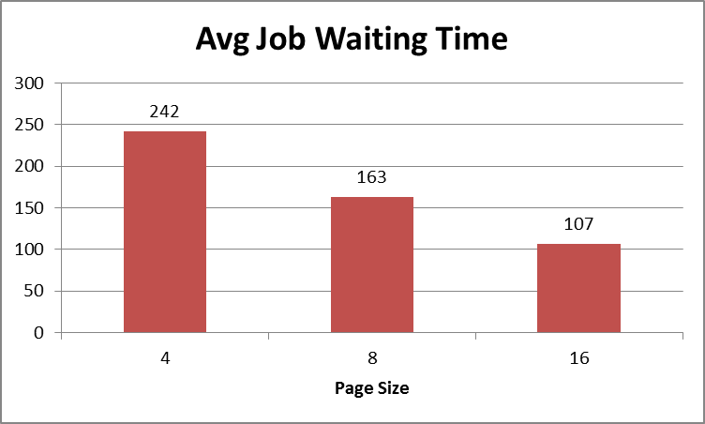

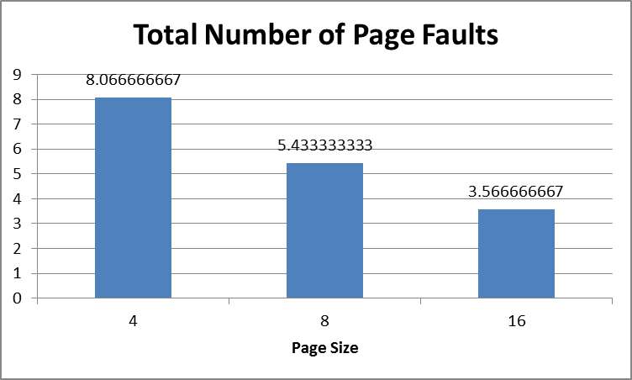

Effects of Varying the Number of CPUs

For our simulator, we found that varying the number of CPUs had almost no impact on performance. We would attribute this to two factors.

First, the CPUs are not the performance bottleneck. The CPUs are relatively fast, completing job execution in under one millisecond. The bottlenecks are IO and the servicing of page faults.

Secondly, regardless of whether there are 1, 4 or 16 virtual CPUs, they are still all running on, and sharing the resources of, a single laptop CPU. A real operating system, of course, would in fact run faster if it could run jobs in parallel on multiple CPUs.

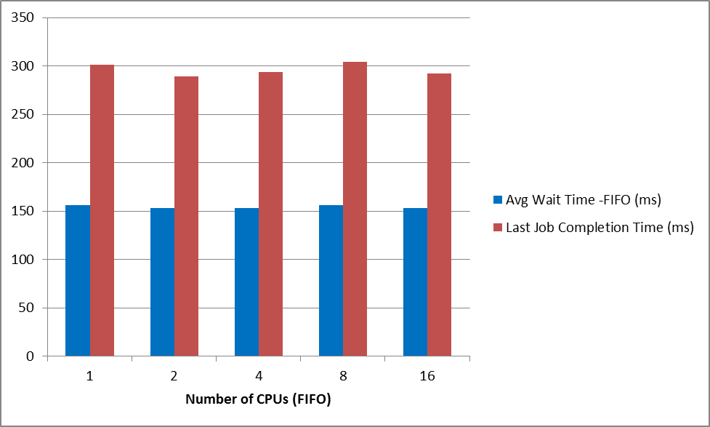
The raw data for this was compiled from the timing1CPU FIFO, timing2CPUs FIFO, timing8CPUs FIFO and timing16CPUs FIFO files, and is included as Appendix C. (timingFIFO for 4 CPUs is included in Appendix B)

Scheduling Algorithm Performance

As in Phase 1, SJF offered the best waiting time performance; scheduling the shortest jobs first avoids the convoy effect and increases throughput. FIFO and Priority were not as good.

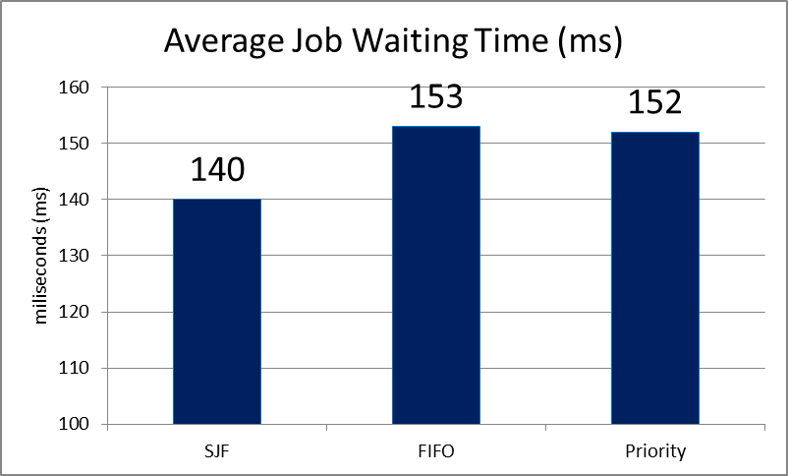

The raw data for this was compiled from timingSJF, timingFIFO, and the timingPriority files and is included as Appendix D.

Comparison with Phase 1a and Phase 1b

Phase 1a had no cache, and performance was relatively bad. Adding the cache in Phase 1b significantly improved performance by reducing the amount of IO, and by conducting it all in one chunk, after the job was run.

In Phase 2, we took a big performance hit by adding paging. However, we found that performance can be improved by increasing the page size.

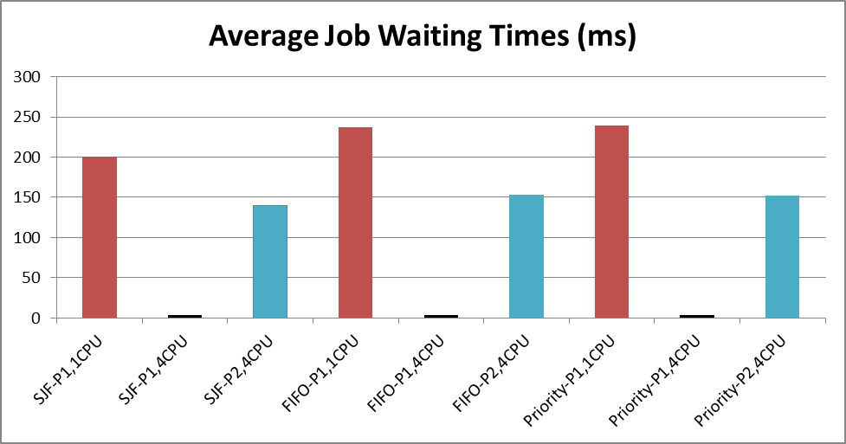
Phase 1a single CPU. No cache.

Phase 1b 4 CPUs. Cache added.

Phase 2 4 CPUs. Paging added.

Avg Job Waiting Times
SJF-P1,1CPU | SJF-P1,4CPU | SJF-P2,4CPU | FIFO-P1,1CPU | FIFO-P1,4CPU | FIFO-P2,4CPU | Priority-P1,1CPU | Priority-P1,4CPU | Priority-P2,4CPU
200.8926 | 3.42 | 140 | 237.4083 | 3.61 | 153 | 239.5568 | 3.85 | 152

Conclusions

In Phase 2, we found that paging was a big performance hit, although it allowed more jobs to be loaded simultaneously, and with less memory usage. Furthermore, we could reduce the performance penalty by increasing the page size, which decreased the number of page faults.

As in Phase 1, SJF had the best performance of all the scheduling algorithms, and caching was a significant performance boost.

In this project as a whole, we covered the basics of job scheduling, memory management, context switching, paging, IO, and synchronization, among other concepts.

We are proud of the fact that - so far as we can tell - this simulator runs without bugs, and handles race conditions appropriately. Of course, the powerful Java synchronization constructs made this task significantly easier.

Constructing this simulator was a huge accomplishment, and we look forward to the programming challenges of the future!

Appendix A: QueueWatch

QueueWatch FIFO
Ready/waiting/done/free frames:
29 0 0 136
28 0 0 136
27 0 0 136
26 0 0 136
25 4 0 135
24 4 0 135
23 5 0 135
22 6 0 135
21 7 0 135
20 7 0 135
19 8 0 135
18 9 0 135
17 9 0 135
16 10 0 135
15 11 0 135
14 12 0 135
13 14 0 135
12 16 0 135
11 16 0 135
10 16 0 135
9 17 0 135
8 18 0 135
7 19 0 135
6 20 0 135
5 21 0 135
4 22 0 135
3 23 0 135
2 24 0 135
1 25 0 135
0 26 0 135
0 28 0 134
0 28 0 133
0 28 0 132
0 28 0 131
0 28 0 130
0 28 0 129
0 28 0 128
0 28 0 127
0 28 0 126
0 27 0 125
0 27 0 124
0 27 0 123
0 27 0 122
0 27 0 121
0 27 0 120
0 27 0 119
0 27 0 118
0 27 0 117
0 27 0 116
0 28 0 115
0 28 0 114
0 28 0 113
0 28 0 112
0 27 0 111
0 27 1 120
0 27 1 120
0 26 1 120
0 26 2 120
0 26 2 130
0 26 2 130
0 26 2 130
0 25 2 130
0 25 3 139
0 25 3 139
0 25 3 139
0 25 3 139
0 24 4 144
0 24 4 144
0 24 4 144
0 24 4 144
0 24 4 144
0 24 4 143
0 24 4 142
0 23 4 141
0 24 4 140
0 24 4 139
0 24 4 138
0 24 4 137
0 24 4 136
0 24 4 135
0 24 4 134
0 24 4 133
0 24 4 132
0 23 4 131
0 23 5 136
0 23 5 136
0 22 6 136
0 22 6 146
0 22 6 146
0 21 7 146
0 21 7 146
0 21 7 155
0 21 7 155
0 20 7 155
0 21 7 155
0 21 7 155
0 20 7 154
0 20 7 153
0 21 7 152
0 20 8 156
0 20 8 156
0 20 8 156
0 20 8 156
0 20 8 156
0 20 8 155
0 19 8 154
0 20 8 153
0 20 8 152
0 20 8 151
0 20 8 150
0 20 8 149
0 20 8 148
0 19 8 147
0 19 9 156
0 19 9 156
0 19 9 156
0 19 9 156
0 18 9 155
0 18 10 165
0 18 10 165
0 18 10 165
0 18 10 165
0 18 10 164
0 17 10 163
0 18 10 162
0 18 10 161
0 18 10 160
0 18 10 159
0 17 10 158
0 17 11 167
0 16 11 167
0 17 11 167
0 16 11 167
0 17 11 167
0 17 11 166
0 17 11 165
0 17 11 164
0 17 11 163
0 17 11 162
0 17 11 161
0 17 11 160
0 16 12 169
0 15 12 169
0 15 13 169
0 15 13 169
0 15 13 174
0 15 13 174
0 14 13 174
0 13 14 174
0 14 14 183
0 14 14 183
0 14 14 183
0 14 14 183
0 14 14 182
0 14 14 181
0 13 14 180
0 12 15 185
0 13 15 185
0 13 15 184
0 13 15 183
0 13 15 182
0 13 15 181
0 13 15 180
0 12 16 188
0 11 16 188
0 12 16 188
0 12 16 188
0 12 16 188
0 12 16 187
0 12 16 186
0 12 16 185
0 12 16 184
0 12 16 183
0 11 16 182
0 12 16 181
0 11 16 180
0 11 17 179
0 11 17 189
0 11 17 189
0 10 17 189
0 11 17 189
0 11 17 188
0 10 17 196
0 10 18 196
0 9 18 196
0 10 18 196
0 10 18 196
0 10 18 195
0 9 18 194
0 9 18 193
0 9 19 203
0 9 19 203
0 9 19 202
0 9 19 202
0 9 19 201
0 8 19 200
0 9 19 199
0 9 19 198
0 9 19 197
0 9 19 196
0 8 20 195
0 8 20 200
0 7 20 199
0 7 21 200
0 7 21 209
0 7 21 209
0 7 21 209
0 7 21 209
0 7 21 209
0 7 21 208
0 7 21 207
0 7 21 206
0 7 21 205
0 7 21 204
0 7 21 203
0 6 21 202
0 6 22 212
0 5 22 212
0 6 22 212
0 5 22 212
0 6 22 211
0 6 22 210
0 5 22 209
0 6 22 208
0 6 22 207
0 5 22 214
0 5 23 215
0 4 23 215
0 5 23 215
0 4 23 215
0 5 23 214
0 5 23 213
0 5 23 212
0 5 23 211
0 5 23 210
0 4 23 217
0 3 24 217
0 3 25 217
0 3 25 226
0 2 25 226
0 2 26 226
0 2 26 226
0 1 26 231
0 1 26 230
0 2 26 231
0 2 26 231
0 1 26 230
0 2 26 229
0 1 26 228
0 2 26 227
0 2 26 226
0 1 26 225
0 2 26 224
0 2 26 223
0 2 26 222
0 2 26 221
0 2 26 220
0 1 26 219
0 2 26 218
0 2 26 217
0 2 26 216
0 2 26 215
0 1 26 214
0 1 27 223
0 1 27 223
0 0 28 223
0 0 28 223
0 0 28 233
0 0 29 234
0 0 29 235
0 0 29 245
0 0 29 246
0 0 30 256

QueueWatch Priority
Ready/waiting/done/free frames:
29 0 0 136
28 0 0 136
27 0 0 136
26 0 0 136
25 0 0 136
24 0 0 136
23 0 0 136
22 0 0 136
21 4 0 135
20 7 0 135
19 8 0 135
18 11 0 135
17 12 0 135
16 13 0 135
15 14 0 135
14 15 0 135
13 16 0 135
12 17 0 135
11 18 0 135
10 19 0 135
9 20 0 135
8 21 0 135
7 22 0 135
6 23 0 135
5 24 0 135
4 25 0 135
3 26 0 135
3 26 0 134
2 27 0 134
1 27 0 134
0 29 0 134
0 29 0 133
0 29 0 132
0 28 0 131
0 29 0 130
0 28 0 129
0 28 0 128
0 28 0 127
0 28 0 126
0 28 0 125
0 28 0 124
0 27 1 128
0 27 1 128
0 27 1 128
0 27 1 128
0 27 1 128
0 27 1 127
0 28 1 126
0 27 1 125
0 27 1 124
0 28 1 123
0 28 1 122
0 27 1 121
0 28 1 120
0 27 1 119
0 26 2 124
0 25 3 127
0 25 3 127
0 25 3 127
0 25 3 136
0 25 3 136
0 25 3 136
0 25 3 136
0 26 3 136
0 25 3 135
0 25 3 134
0 26 3 133
0 25 3 132
0 25 3 131
0 26 3 130
0 26 3 129
0 26 3 128
0 26 3 127
0 26 3 126
0 25 3 125
0 25 4 134
0 25 4 134
0 24 4 134
0 23 4 134
0 23 5 144
0 23 5 144
0 23 5 144
0 23 5 144
0 23 5 144
0 23 5 143
0 23 5 142
0 23 5 141
0 23 5 140
0 24 5 139
0 23 5 138
0 23 5 137
0 23 5 136
0 22 6 143
0 23 6 143
0 22 6 143
0 22 6 143
0 23 6 142
0 23 6 141
0 23 6 140
0 22 6 139
0 21 6 138
0 21 8 147
0 20 8 147
0 20 8 147
0 21 8 147
0 20 8 157
0 20 8 157
0 20 9 157
0 19 9 157
0 19 9 162
0 19 9 162
0 19 9 162
0 18 10 166
0 18 10 166
0 19 10 166
0 18 10 166
0 18 10 166
0 18 10 165
0 18 10 164
0 18 10 163
0 18 10 162
0 18 10 161
0 18 10 160
0 19 10 159
0 19 10 158
0 18 10 157
0 18 10 156
0 18 10 155
0 17 10 154
0 16 12 163
0 16 12 163
0 17 12 163
0 16 12 172
0 16 12 172
0 16 12 172
0 16 12 172
0 16 12 172
0 16 12 171
0 16 12 170
0 16 12 169
0 16 12 168
0 15 12 167
0 15 13 176
0 15 13 176
0 15 13 176
0 15 13 176
0 15 13 175
0 15 13 174
0 15 13 173
0 14 14 172
0 14 14 177
0 14 14 177
0 14 14 177
0 14 14 177
0 14 14 176
0 13 15 175
0 13 15 180
0 13 15 180
0 13 15 180
0 13 15 180
0 12 16 188
0 12 16 188
0 12 16 188
0 12 16 188
0 12 16 188
0 12 16 187
0 11 17 195
0 11 17 195
0 11 17 195
0 11 17 195
0 11 17 195
0 11 17 194
0 11 17 193
0 11 17 192
0 11 17 191
0 11 17 190
0 10 18 194
0 10 18 194
0 10 18 194
0 9 19 199
0 9 19 199
0 9 19 199
0 9 19 199
0 9 19 199
0 10 19 198
0 10 19 197
0 9 19 196
0 10 19 195
0 9 19 194
0 10 19 193
0 10 19 192
0 10 19 191
0 9 19 190
0 9 20 199
0 8 20 199
0 8 20 199
0 7 21 199
0 8 21 209
0 7 21 209
0 7 21 209
0 8 21 209
0 7 21 209
0 7 21 208
0 7 21 207
0 7 21 206
0 7 21 205
0 6 21 204
0 7 21 203
0 8 21 202
0 7 21 201
0 8 21 200
0 8 21 199
0 7 21 198
0 8 21 197
0 7 21 196
0 7 21 195
0 7 21 194
0 7 21 193
0 6 22 202
0 6 22 202
0 6 23 202
0 5 23 202
0 6 23 212
0 5 23 212
0 4 24 212
0 4 24 212
0 4 24 221
0 4 24 221
0 4 24 221
0 5 24 221
0 4 24 221
0 4 24 221
0 4 24 220
0 4 24 219
0 4 24 218
0 4 24 217
0 4 24 216
0 3 25 215
0 3 25 220
0 3 25 220
0 3 25 220
0 3 25 219
0 3 25 218
0 3 25 217
0 4 25 216
0 3 25 215
0 3 25 214
0 3 25 213
0 3 25 212
0 4 25 211
0 3 25 210
0 3 26 218
0 2 26 218
0 1 27 218
0 1 28 218
0 1 28 227
0 0 28 227
0 0 28 227
0 0 28 227
0 0 28 236
0 0 28 236
0 0 28 236
0 0 28 236
0 0 28 236
0 1 28 236
0 0 28 235
0 1 28 234
0 1 28 233
0 0 28 232
0 1 28 231
0 0 28 230
0 0 28 230
0 0 30 256

QueueWatch SJF
Ready/waiting/done/free frames:
29 0 0 136
28 0 0 136
27 0 0 136
26 0 0 136
25 0 0 136
24 0 0 136
23 0 0 136
22 0 0 136
21 5 0 135
20 7 0 135
19 9 0 135
18 9 0 135
17 12 0 135
16 12 0 135
15 14 0 135
14 15 0 135
13 16 0 135
12 17 0 135
11 18 0 135
10 19 0 135
9 19 0 135
8 21 0 135
7 22 0 135
6 22 0 135
5 24 0 135
4 25 0 135
3 26 0 135
2 27 0 135
1 28 0 135
0 29 0 135
0 29 0 134
0 29 0 133
0 29 0 132
0 29 0 131
0 28 0 130
0 28 0 129
0 28 0 128
0 29 0 127
0 28 0 126
0 28 0 125
0 27 0 124
0 27 0 123
0 27 0 122
0 26 0 124
0 27 1 126
0 28 1 126
0 27 1 126
0 27 1 125
0 27 1 124
0 27 1 123
0 27 1 122
0 27 1 121
0 26 2 125
0 26 2 125
0 25 3 130
0 24 3 130
0 23 5 130
0 23 6 135
0 22 6 135
0 22 6 135
0 23 6 135
0 22 6 140
0 22 6 140
0 23 6 140
0 22 6 140
0 22 6 145
0 22 6 145
0 21 7 145
0 21 8 145
0 21 8 150
0 21 8 150
0 20 8 150
0 20 8 150
0 20 8 155
0 20 8 155
0 21 8 155
0 20 8 155
0 20 8 155
0 20 8 154
0 21 8 153
0 20 8 152
0 20 8 151
0 20 8 150
0 20 8 149
0 20 8 148
0 20 8 147
0 20 8 146
0 20 8 145
0 20 8 144
0 20 8 143
0 20 8 142
0 20 8 141
0 20 8 140
0 20 8 139
0 20 8 138
0 20 8 137
0 20 8 136
0 20 8 135
0 20 8 134
0 19 8 133
0 18 10 142
0 17 11 142
0 17 12 142
0 16 12 150
0 17 12 150
0 16 12 150
0 16 12 159
0 16 12 159
0 16 12 159
0 16 12 159
0 16 12 159
0 16 12 168
0 16 12 168
0 16 12 168
0 16 12 168
0 16 12 168
0 16 12 168
0 16 12 167
0 16 12 166
0 16 12 165
0 16 12 164
0 16 12 163
0 16 12 162
0 16 12 161
0 16 12 160
0 15 13 168
0 15 13 168
0 15 13 168
0 15 13 168
0 15 13 168
0 15 13 168
0 16 13 167
0 15 13 166
0 15 13 165
0 14 13 164
0 15 13 163
0 15 13 162
0 16 13 161
0 16 13 160
0 15 13 159
0 15 13 158
0 15 13 157
0 15 13 156
0 15 13 155
0 15 13 154
0 15 13 153
0 14 14 161
0 14 14 161
0 13 14 161
0 13 15 161
0 13 15 170
0 13 16 170
0 12 16 170
0 12 16 170
0 12 16 179
0 11 17 179
0 11 17 179
0 11 17 179
0 11 17 188
0 11 17 188
0 11 17 188
0 11 17 188
0 11 17 188
0 11 17 187
0 11 17 186
0 10 17 194
0 10 18 194
0 10 18 194
0 10 18 194
0 10 18 194
0 10 18 193
0 10 18 192
0 10 18 191
0 10 18 190
0 10 18 189
0 11 18 188
0 10 18 187
0 10 18 186
0 10 18 185
0 11 18 184
0 10 18 183
0 11 18 182
0 10 18 181
0 10 18 180
0 10 19 188
0 9 19 188
0 10 19 188
0 9 19 188
0 8 19 188
0 7 20 196
0 8 20 196
0 7 21 196
0 7 21 196
0 7 21 205
0 7 21 205
0 7 21 205
0 7 22 215
0 6 22 215
0 6 22 215
0 6 22 215
0 6 22 215
0 6 22 214
0 6 22 213
0 6 22 212
0 6 22 211
0 6 22 210
0 6 22 209
0 6 22 208
0 6 22 207
0 6 22 206
0 5 22 205
0 6 22 204
0 6 22 203
0 6 22 202
0 6 22 201
0 6 22 200
0 6 22 199
0 6 22 198
0 6 22 197
0 7 22 196
0 6 22 195
0 6 22 194
0 6 22 193
0 6 22 192
0 6 22 191
0 6 22 190
0 5 23 199
0 4 24 199
0 5 24 199
0 4 24 199
0 4 24 209
0 4 24 209
0 4 24 209
0 4 24 209
0 4 25 208
0 3 25 218
0 3 25 218
0 3 25 218
0 2 26 228
0 2 26 228
0 2 26 228
0 2 26 228
0 2 26 228
0 2 26 227
0 2 26 226
0 2 26 225
0 2 26 224
0 2 26 223
0 2 26 222
0 2 26 221
0 2 26 220
0 3 26 219
0 2 26 218
0 3 26 217
0 3 26 216
0 2 26 215
0 3 26 214
0 3 26 213
0 2 26 212
0 3 26 211
0 2 26 210
0 1 27 219
0 1 27 219
0 0 28 219
0 0 28 219
0 1 28 229
0 0 28 229
0 0 28 229
0 1 28 229
0 0 28 229
0 0 28 228
0 0 29 238
0 0 30 256

QueueWatch FIFO with Slow Disk
Ready/waiting/done/free frames:
29 0 0 136
28 0 0 136
27 0 0 136
26 0 0 136
25 0 0 136
24 0 0 136
23 0 0 136
22 0 0 136
21 7 0 136
20 6 0 136
19 8 0 135
18 9 0 135
17 10 0 135
16 11 0 135
15 12 0 135
14 13 0 135
13 16 0 135
12 17 0 135
11 18 0 135
10 18 0 135
9 19 0 135
8 20 0 135
7 20 0 135
6 21 0 135
5 22 0 135
4 23 0 135
3 24 0 135
2 26 0 135
1 26 0 135
0 28 0 135
0 29 0 134
0 29 0 133
0 29 0 132
0 28 0 131
0 28 0 130
0 28 0 129
0 28 0 128
0 28 0 127
0 28 0 126
0 28 0 125
0 28 0 124
0 28 0 123
0 28 0 122
0 28 0 121
0 28 0 120
0 29 0 119
0 28 0 118
0 28 0 117
0 29 0 116
0 28 0 115
0 28 0 114
0 28 0 113
0 27 0 115
0 26 2 120
0 27 2 119
0 27 2 118
0 26 2 117
0 26 2 116
0 26 2 115
0 26 2 114
0 26 2 113
0 26 2 112
0 26 2 112
0 27 2 111
0 26 2 110
0 26 2 109
0 25 3 108
0 25 3 107
0 25 4 106
0 24 4 105
0 24 4 104
0 25 4 104
0 24 4 103
0 24 4 102
0 24 4 101
0 25 4 100
0 24 4 99
0 25 4 98
0 24 4 97
0 24 4 97
0 24 4 96
0 24 4 95
0 23 5 94
0 23 5 93
0 23 5 92
0 23 6 91
0 22 6 90
0 22 6 90
0 22 6 89
0 23 6 88
0 22 6 87
0 21 7 86
0 21 7 85
0 22 7 84
0 21 7 83
0 21 7 93
0 21 7 92
0 21 7 91
0 20 8 90
0 20 8 89
0 21 8 88
0 20 8 87
0 20 8 87
0 20 8 86
0 20 8 85
0 20 8 84
0 20 8 83
0 21 8 82
0 20 8 81
0 20 8 80
0 20 8 79
0 20 8 79
0 20 9 78
0 19 9 77
0 20 9 76
0 20 9 75
0 19 9 74
0 18 10 73
0 18 10 72
0 18 10 72
0 19 10 71
0 18 10 70
0 18 10 69
0 18 10 68
0 18 10 67
0 18 10 66
0 18 10 65
0 18 10 64
0 18 10 63
0 18 10 72
0 17 11 71
0 17 11 70
0 17 11 69
0 17 11 68
0 18 11 67
0 17 11 66
0 18 11 65
0 17 11 65
0 18 11 64
0 17 11 63
0 17 11 62
0 17 12 61
0 16 12 60
0 16 12 59
0 15 13 58
0 15 13 57
0 14 13 57
0 14 14 56
0 14 14 55
0 14 14 54
0 14 14 53
0 14 14 52
0 14 14 51
0 14 14 50
0 13 15 49
0 13 15 49
0 13 15 48
0 13 15 47
0 13 15 46
0 13 15 45
0 13 15 44
0 13 15 43
0 13 15 42
0 13 15 41
0 13 15 46
0 12 16 45
0 12 16 44
0 12 16 43
0 12 16 42
0 12 16 41
0 13 16 41
0 12 16 40
0 12 16 39
0 12 16 38
0 12 16 37
0 11 17 36
0 11 17 35
0 11 17 34
0 11 17 33
0 11 17 33
0 11 17 32
0 10 18 31
0 10 18 30
0 10 18 29
0 11 18 28
0 10 18 27
0 10 18 26
0 10 18 25
0 10 18 24
0 10 18 24
0 10 18 23
0 9 19 22
0 9 19 21
0 9 19 20
0 10 19 19
0 9 19 18
0 10 19 28
0 9 19 27
0 9 19 26
0 9 19 25
0 8 20 24
0 7 21 23
0 7 21 22
0 7 21 22
0 8 21 21
0 8 21 20
0 7 21 19
0 7 21 18
0 7 21 17
0 7 21 16
0 7 21 15
0 8 21 14
0 7 21 14
0 7 21 13
0 7 21 12
0 7 21 11
0 7 21 10
0 7 21 9
0 6 22 8
0 5 22 7
0 7 22 7
0 6 22 6
0 6 22 5
0 7 22 4
0 6 22 3
0 6 22 2
0 6 22 1
0 5 23 0
0 5 23 5
0 5 23 4
0 4 24 3
0 5 24 2
0 4 24 1
0 4 24 0
0 4 24 0
0 4 24 0
0 5 24 0
0 4 24 0
0 4 24 8
0 3 25 7
0 2 26 6
0 2 26 5
0 2 26 4
0 2 26 3
0 3 26 2
0 2 26 2
0 2 26 1
0 2 26 0
0 2 26 0
0 2 26 0
0 2 26 0
0 2 26 4
0 2 26 3
0 2 26 2
0 2 26 1
0 3 26 0
0 3 26 0
0 2 26 0
0 1 27 0
0 1 27 0
0 1 27 8
0 1 27 7
0 1 27 6
0 1 28 5
0 0 28 4
0 1 28 4
0 1 28 2
0 0 28 2
0 0 28 1
0 0 28 0
0 0 29 0
0 0 29 0
0 0 30 256

Appendix B: Results From Changing the Page Size

timingFIFO (pagesize 4)

Job# | NumPageFaults | AvgWaitTime | AvgCompletionTime | AvgExecutionTime | IOTime | FaultServiceTotal | Data is in milliseconds (ms)
1 | 10 | 21 | 29 | 0 | 8 | 12
2 | 10 | 24 | 32 | 0 | 7 | 11
3 | 9 | 33 | 39 | 0 | 6 | 11
4 | 5 | 42 | 47 | 0 | 5 | 6
5 | 9 | 58 | 64 | 0 | 6 | 10
7 | 8 | 62 | 68 | 0 | 7 | 9
6 | 7 | 65 | 71 | 0 | 6 | 8
8 | 5 | 77 | 82 | 0 | 5 | 6
9 | 9 | 91 | 98 | 0 | 8 | 11
10 | 10 | 97 | 105 | 0 | 8 | 12
11 | 10 | 113 | 122 | 0 | 9 | 12
12 | 10 | 125 | 133 | 0 | 7 | 12
13 | 8 | 129 | 136 | 0 | 8 | 10
14 | 5 | 137 | 141 | 0 | 4 | 6
16 | 3 | 145 | 147 | 0 | 2 | 3
15 | 9 | 153 | 160 | 0 | 7 | 11
17 | 10 | 166 | 173 | 0 | 7 | 12
18 | 9 | 173 | 179 | 0 | 7 | 10
19 | 9 | 185 | 191 | 0 | 6 | 10
21 | 5 | 196 | 201 | 0 | 5 | 7
20 | 9 | 198 | 206 | 0 | 8 | 11
22 | 10 | 218 | 226 | 0 | 8 | 12
23 | 9 | 228 | 235 | 0 | 7 | 13
24 | 9 | 236 | 243 | 0 | 8 | 11
26 | 4 | 247 | 251 | 0 | 4 | 5
25 | 7 | 247 | 252 | 0 | 5 | 8
27 | 10 | 269 | 276 | 0 | 8 | 12
28 | 10 | 275 | 282 | 0 | 8 | 12
29 | 9 | 281 | 288 | 0 | 7 | 11
30 | 5 | 288 | 294 | 0 | 5 | 6

For All Jobs After running 5 iterations:
#Faults AvgWait AvgCompletion AvgIOWait AvgFaultService
8.066666667 153 159 6.533333333 9.666666667
timingFIFO pagesize8

Job# | NumPageFaults | AvgWaitTime | AvgCompletionTime | AvgExecutionTime | IOTime | FaultServiceTotal | Data is in milliseconds (ms)
1 | 7 | 11 | 17 | 1 | 5 | 7
2 | 6 | 13 | 18 | 1 | 4 | 6
3 | 6 | 22 | 27 | 1 | 4 | 6
4 | 4 | 25 | 29 | 1 | 3 | 4
5 | 6 | 31 | 36 | 1 | 4 | 6
6 | 6 | 37 | 42 | 1 | 4 | 6
7 | 4 | 39 | 43 | 1 | 3 | 4
8 | 4 | 45 | 51 | 1 | 5 | 4
9 | 6 | 61 | 65 | 0 | 4 | 10
10 | 6 | 62 | 66 | 0 | 4 | 8
11 | 7 | 72 | 78 | 0 | 6 | 8
12 | 6 | 80 | 85 | 0 | 5 | 6
13 | 6 | 84 | 88 | 0 | 4 | 9
14 | 3 | 89 | 91 | 0 | 2 | 3
16 | 3 | 100 | 102 | 0 | 2 | 4
15 | 6 | 101 | 108 | 0 | 7 | 8
17 | 6 | 109 | 116 | 0 | 7 | 9
18 | 6 | 117 | 124 | 0 | 7 | 9
19 | 6 | 132 | 137 | 0 | 5 | 10
21 | 4 | 140 | 143 | 0 | 3 | 5
20 | 6 | 138 | 144 | 0 | 6 | 8
22 | 6 | 150 | 156 | 0 | 6 | 7
23 | 6 | 156 | 162 | 0 | 6 | 8
24 | 6 | 167 | 171 | 0 | 4 | 8
25 | 5 | 172 | 175 | 0 | 3 | 5
26 | 3 | 174 | 176 | 0 | 2 | 4
27 | 7 | 187 | 194 | 0 | 7 | 8
28 | 6 | 190 | 195 | 0 | 5 | 7
29 | 6 | 192 | 198 | 0 | 6 | 6
30 | 4 | 200 | 203 | 0 | 3 | 5

For All Jobs After running 1 iterations:
#Faults AvgWait AvgCompletion AvgIOWait AvgFaultService
5.433333333 103 108 4.533333333 6.6

timingFIFO pagesize16

Job# | NumPageFaults | AvgWaitTime | AvgCompletionTime | AvgExecutionTime | IOTime | FaultServiceTotal | Data is in milliseconds (ms)
2 | 4 | 9 | 14 | 1 | 4 | 6
1 | 4 | 11 | 15 | 1 | 3 | 5
3 | 4 | 19 | 24 | 1 | 4 | 4
4 | 3 | 22 | 25 | 1 | 2 | 4
5 | 4 | 26 | 30 | 1 | 3 | 6
7 | 3 | 32 | 35 | 1 | 2 | 3
6 | 4 | 32 | 36 | 1 | 3 | 4
8 | 3 | 36 | 39 | 1 | 2 | 3
9 | 4 | 44 | 47 | 0 | 3 | 5
10 | 4 | 47 | 50 | 0 | 3 | 5
11 | 4 | 51 | 54 | 0 | 3 | 4
12 | 4 | 57 | 60 | 0 | 3 | 4
13 | 4 | 58 | 61 | 0 | 3 | 4
14 | 2 | 61 | 62 | 0 | 1 | 2
16 | 2 | 66 | 67 | 0 | 1 | 2
15 | 4 | 69 | 72 | 0 | 3 | 5
17 | 4 | 73 | 76 | 0 | 3 | 4
18 | 4 | 77 | 80 | 0 | 3 | 4
19 | 4 | 82 | 85 | 0 | 3 | 5
20 | 4 | 86 | 90 | 0 | 4 | 4
21 | 3 | 89 | 91 | 0 | 2 | 4
22 | 4 | 95 | 98 | 0 | 3 | 6
23 | 3 | 98 | 101 | 0 | 3 | 4
24 | 4 | 104 | 107 | 0 | 3 | 4
25 | 3 | 106 | 108 | 0 | 2 | 3
26 | 2 | 108 | 109 | 0 | 1 | 2
27 | 4 | 117 | 122 | 0 | 5 | 5
28 | 4 | 118 | 123 | 0 | 5 | 7
29 | 4 | 126 | 129 | 0 | 3 | 5
30 | 3 | 128 | 130 | 0 | 2 | 4

For All Jobs After running 1 iterations:
#Faults AvgWait AvgCompletion AvgIOWait AvgFaultService
3.566666667 68 71 2.833333333 4.233333333

Job # of IO Ops
1 32
2 32
3 32
4 12
5 32
6 32
7 12
8 12
9 32
10 32
11 32
12 32
13 32
14 10
15 29
16 5
17 32
18 32
19 26
20 32
21 13
22 32
23 29
24 32
25 17
26 8
27 32
28 32
29 32
30 11
Appendix C: Results of Varying the Number of CPUs

Timing – 1 cpu FIFO
Job# | NumPageFaults | AvgWaitTime | AvgCompletionTime | AvgExecutionTime | IOTime | FaultServiceTotal | Data is in milliseconds (ms)
1 | 10 | 15 | 23 | 1 | 7 | 11
2 | 10 | 22 | 28 | 0 | 6 | 10
4 | 5 | 35 | 39 | 0 | 4 | 5
3 | 9 | 34 | 40 | 0 | 6 | 10
5 | 10 | 52 | 58 | 0 | 6 | 11
6 | 9 | 57 | 65 | 0 | 8 | 10
7 | 5 | 62 | 66 | 0 | 4 | 6
8 | 5 | 72 | 76 | 0 | 4 | 6
9 | 9 | 85 | 94 | 0 | 9 | 11
10 | 10 | 94 | 102 | 0 | 8 | 12
11 | 10 | 110 | 119 | 0 | 9 | 16
12 | 10 | 120 | 131 | 0 | 11 | 13
14 | 4 | 134 | 139 | 0 | 5 | 6
13 | 9 | 132 | 140 | 0 | 8 | 11
16 | 3 | 147 | 149 | 0 | 2 | 4
15 | 9 | 161 | 167 | 0 | 6 | 12
17 | 10 | 169 | 176 | 0 | 7 | 12
18 | 9 | 174 | 184 | 0 | 10 | 10
19 | 9 | 195 | 200 | 0 | 5 | 13
21 | 5 | 201 | 207 | 0 | 6 | 5
20 | 9 | 208 | 216 | 1 | 7 | 11
22 | 10 | 230 | 240 | 0 | 10 | 18
23 | 9 | 237 | 247 | 0 | 10 | 13
24 | 9 | 252 | 260 | 0 | 8 | 13
25 | 7 | 259 | 264 | 0 | 5 | 10
26 | 4 | 265 | 268 | 0 | 3 | 4
27 | 10 | 282 | 293 | 0 | 11 | 10
28 | 10 | 288 | 296 | 0 | 8 | 11
29 | 9 | 296 | 302 | 0 | 6 | 12
30 | 5 | 301 | 305 | 0 | 4 | 6

For All Jobs After running 1 iterations:
#Faults AvgWait AvgCompletion AvgIOWait AvgFaultService
8.066666667 156 163 6.766666667 10.06666667

Timing – 2 cpus FIFO

Job# | NumPageFaults | AvgWaitTime | AvgCompletionTime | AvgExecutionTime | IOTime | FaultServiceTotal | Data is in milliseconds (ms)
1 | 10 | 20 | 29 | 2 | 7 | 11
2 | 10 | 24 | 32 | 2 | 6 | 11
3 | 9 | 33 | 39 | 0 | 6 | 9
4 | 5 | 40 | 44 | 0 | 4 | 6
5 | 10 | 59 | 65 | 0 | 6 | 11
6 | 9 | 57 | 66 | 0 | 9 | 9
7 | 5 | 66 | 70 | 0 | 4 | 7
8 | 5 | 75 | 81 | 0 | 6 | 5
9 | 9 | 87 | 96 | 0 | 9 | 12
10 | 10 | 103 | 110 | 0 | 7 | 16
11 | 10 | 106 | 116 | 1 | 9 | 12
14 | 4 | 130 | 133 | 0 | 3 | 4
12 | 10 | 129 | 137 | 0 | 8 | 12
13 | 9 | 136 | 143 | 0 | 7 | 12
16 | 3 | 150 | 152 | 0 | 2 | 3
15 | 9 | 153 | 160 | 0 | 7 | 11
17 | 10 | 172 | 178 | 0 | 6 | 12
18 | 9 | 177 | 185 | 0 | 8 | 11
19 | 9 | 190 | 197 | 0 | 7 | 10
20 | 9 | 198 | 205 | 0 | 7 | 12
21 | 5 | 204 | 209 | 0 | 5 | 6
22 | 10 | 221 | 227 | 0 | 6 | 12
23 | 9 | 231 | 238 | 0 | 7 | 10
24 | 9 | 236 | 243 | 0 | 7 | 11
25 | 7 | 244 | 249 | 0 | 5 | 7
26 | 4 | 250 | 253 | 0 | 3 | 6
27 | 10 | 267 | 274 | 0 | 7 | 10
28 | 10 | 273 | 279 | 0 | 6 | 10
29 | 9 | 276 | 282 | 0 | 6 | 9
30 | 5 | 285 | 289 | 0 | 4 | 5

For All Jobs After running 1 iterations:
#Faults AvgWait AvgCompletion AvgIOWait AvgFaultService
8.066666667 153 159 6.133333333 9.4

Timing – 8 cpus FIFO

Job# | NumPageFaults | AvgWaitTime | AvgCompletionTime | AvgExecutionTime | IOTime | FaultServiceTotal | Data is in milliseconds (ms)
1 | 10 | 27 | 36 | 1 | 8 | 12
2 | 10 | 29 | 37 | 1 | 7 | 11
3 | 9 | 32 | 40 | 1 | 7 | 12
4 | 5 | 44 | 49 | 1 | 4 | 5
5 | 10 | 57 | 67 | 2 | 8 | 12
7 | 5 | 66 | 74 | 1 | 7 | 5
6 | 9 | 68 | 75 | 1 | 6 | 12
8 | 5 | 77 | 83 | 2 | 4 | 6
9 | 9 | 91 | 99 | 2 | 6 | 11
10 | 10 | 99 | 109 | 2 | 8 | 11
11 | 10 | 114 | 126 | 2 | 10 | 13
12 | 10 | 125 | 134 | 2 | 7 | 13
13 | 9 | 132 | 140 | 2 | 6 | 10
14 | 4 | 138 | 143 | 2 | 3 | 5
16 | 3 | 145 | 149 | 2 | 2 | 3
15 | 9 | 156 | 163 | 1 | 6 | 10
17 | 10 | 171 | 177 | 0 | 6 | 12
18 | 9 | 175 | 183 | 0 | 8 | 9
19 | 9 | 185 | 190 | 0 | 5 | 11
21 | 5 | 197 | 202 | 0 | 5 | 6
20 | 9 | 202 | 210 | 0 | 8 | 14
22 | 10 | 224 | 233 | 0 | 9 | 11
23 | 9 | 229 | 237 | 0 | 8 | 12
24 | 9 | 245 | 253 | 0 | 8 | 13
26 | 4 | 251 | 255 | 0 | 4 | 6
25 | 7 | 252 | 259 | 0 | 7 | 7
27 | 10 | 277 | 287 | 0 | 10 | 12
28 | 10 | 283 | 290 | 0 | 7 | 14
29 | 9 | 286 | 295 | 0 | 9 | 10
30 | 5 | 298 | 304 | 0 | 6 | 7

For All Jobs After running 1 iterations:
#Faults AvgWait AvgCompletion AvgIOWait AvgFaultService
8.066666667 156 163 6.633333333 9.833333333

Timing – 16 cpus FIFO

Job# | NumPageFaults | AvgWaitTime | AvgCompletionTime | AvgExecutionTime | IOTime | FaultServiceTotal | Data is in milliseconds (ms)
1 | 10 | 18 | 27 | 2 | 7 | 10
2 | 10 | 23 | 30 | 1 | 6 | 10
3 | 9 | 29 | 36 | 1 | 6 | 9
4 | 5 | 35 | 40 | 1 | 4 | 5
7 | 5 | 54 | 62 | 1 | 7 | 7
5 | 10 | 57 | 65 | 1 | 7 | 13
6 | 9 | 62 | 72 | 1 | 9 | 10
8 | 5 | 73 | 78 | 0 | 5 | 6
9 | 9 | 88 | 98 | 1 | 9 | 10
10 | 10 | 99 | 105 | 0 | 6 | 14
11 | 10 | 109 | 117 | 0 | 8 | 12
12 | 10 | 121 | 127 | 0 | 6 | 11
14 | 4 | 128 | 131 | 0 | 3 | 4
13 | 9 | 130 | 136 | 0 | 6 | 10
16 | 3 | 140 | 142 | 0 | 2 | 3
15 | 9 | 145 | 151 | 0 | 6 | 9
17 | 10 | 160 | 167 | 0 | 7 | 11
18 | 9 | 163 | 170 | 0 | 7 | 9
19 | 9 | 181 | 187 | 0 | 6 | 13
21 | 5 | 186 | 192 | 0 | 6 | 5
20 | 9 | 190 | 198 | 0 | 8 | 11
22 | 10 | 213 | 220 | 0 | 7 | 14
23 | 9 | 218 | 229 | 0 | 11 | 10
24 | 9 | 226 | 235 | 0 | 9 | 11
25 | 7 | 240 | 244 | 0 | 4 | 11
26 | 4 | 240 | 247 | 0 | 7 | 4
27 | 10 | 267 | 276 | 0 | 9 | 14
28 | 10 | 271 | 280 | 0 | 9 | 13
29 | 9 | 279 | 286 | 0 | 7 | 13
30 | 5 | 287 | 292 | 0 | 5 | 5

For All Jobs After running 1 iterations:
#Faults AvgWait AvgCompletion AvgIOWait AvgFaultService
8.066666667 148 155 6.633333333 9.566666667

Appendix D: Scheduling Algorithm Results

Timing – SJF
Job# | Num Page Faults | AvgWait Time | Avg Completion Time | Avg Execution Time | IO Time | Fault Service Total | Data is in milliseconds (ms)
14 | 3 | 15 | 18 | 0 | 2 | 4
26 | 4 | 19 | 23 | 0 | 4 | 5
7 | 5 | 20 | 25 | 0 | 5 | 6
8 | 5 | 26 | 31 | 0 | 5 | 6
16 | 4 | 32 | 37 | 0 | 4 | 5
30 | 5 | 35 | 40 | 0 | 5 | 6
4 | 5 | 38 | 44 | 0 | 6 | 6
21 | 5 | 41 | 46 | 0 | 5 | 6
25 | 9 | 75 | 83 | 0 | 7 | 10
23 | 10 | 80 | 88 | 0 | 8 | 12
27 | 9 | 82 | 90 | 0 | 8 | 12
11 | 10 | 83 | 92 | 0 | 9 | 12
1 | 8 | 105 | 111 | 0 | 6 | 9
15 | 9 | 135 | 142 | 0 | 7 | 11
3 | 9 | 137 | 144 | 0 | 8 | 11
29 | 9 | 139 | 147 | 0 | 8 | 11
24 | 9 | 143 | 150 | 0 | 7 | 11
13 | 9 | 166 | 173 | 0 | 7 | 12
9 | 9 | 181 | 189 | 0 | 7 | 10
20 | 9 | 184 | 191 | 0 | 8 | 11
6 | 9 | 186 | 194 | 0 | 8 | 11
18 | 9 | 191 | 199 | 0 | 7 | 11
17 | 10 | 231 | 239 | 0 | 8 | 13
2 | 10 | 234 | 242 | 0 | 8 | 13
22 | 10 | 238 | 245 | 0 | 7 | 12
12 | 10 | 247 | 256 | 0 | 9 | 13
19 | 10 | 279 | 287 | 0 | 7 | 12
28 | 10 | 285 | 291 | 0 | 7 | 13
10 | 10 | 287 | 295 | 0 | 8 | 13
5 | 10 | 291 | 297 | 0 | 7 | 12

For All Jobs After running 5 iterations:
#Faults AvgWait AvgCompletion AvgIOWait AvgFaultService
8.1 140 147 6.733333333 9.966666667

Timing – FIFO

Job# | NumPageFaults | AvgWaitTime | AvgCompletionTime | AvgExecutionTime | IOTime | FaultServiceTotal | Data is in milliseconds (ms)
1 | 10 | 21 | 29 | 0 | 8 | 12
2 | 10 | 24 | 32 | 0 | 7 | 11
3 | 9 | 33 | 39 | 0 | 6 | 11
4 | 5 | 42 | 47 | 0 | 5 | 6
5 | 9 | 58 | 64 | 0 | 6 | 10
7 | 8 | 62 | 68 | 0 | 7 | 9
6 | 7 | 65 | 71 | 0 | 6 | 8
8 | 5 | 77 | 82 | 0 | 5 | 6
9 | 9 | 91 | 98 | 0 | 8 | 11
10 | 10 | 97 | 105 | 0 | 8 | 12
11 | 10 | 113 | 122 | 0 | 9 | 12
12 | 10 | 125 | 133 | 0 | 7 | 12
13 | 8 | 129 | 136 | 0 | 8 | 10
14 | 5 | 137 | 141 | 0 | 4 | 6
16 | 3 | 145 | 147 | 0 | 2 | 3
15 | 9 | 153 | 160 | 0 | 7 | 11
17 | 10 | 166 | 173 | 0 | 7 | 12
18 | 9 | 173 | 179 | 0 | 7 | 10
19 | 9 | 185 | 191 | 0 | 6 | 10
21 | 5 | 196 | 201 | 0 | 5 | 7
20 | 9 | 198 | 206 | 0 | 8 | 11
22 | 10 | 218 | 226 | 0 | 8 | 12
23 | 9 | 228 | 235 | 0 | 7 | 13
24 | 9 | 236 | 243 | 0 | 8 | 11
26 | 4 | 247 | 251 | 0 | 4 | 5
25 | 7 | 247 | 252 | 0 | 5 | 8
27 | 10 | 269 | 276 | 0 | 8 | 12
28 | 10 | 275 | 282 | 0 | 8 | 12
29 | 9 | 281 | 288 | 0 | 7 | 11
30 | 5 | 288 | 294 | 0 | 5 | 6

For All Jobs After running 5 iterations:
#Faults AvgWait AvgCompletion AvgIOWait AvgFaultService
8.066666667 153 159 6.533333333 9.666666667

Timing – Priority

Job# | NumPageFaults | AvgWaitTime | AvgCompletionTime | AvgExecutionTime | IOTime | FaultServiceTotal | Data is in milliseconds (ms)
8 | 5 | 10 | 14 | 0 | 4 | 6
18 | 9 | 23 | 30 | 0 | 7 | 10
13 | 9 | 24 | 31 | 0 | 7 | 10
22 | 10 | 48 | 55 | 0 | 7 | 12
10 | 10 | 50 | 57 | 0 | 7 | 12
25 | 7 | 71 | 76 | 0 | 5 | 9
12 | 10 | 79 | 87 | 0 | 8 | 11
27 | 10 | 80 | 88 | 0 | 8 | 13
16 | 3 | 91 | 94 | 0 | 2 | 4
30 | 5 | 95 | 101 | 0 | 5 | 7
6 | 9 | 114 | 122 | 0 | 8 | 11
24 | 9 | 116 | 123 | 0 | 7 | 10
3 | 9 | 129 | 137 | 0 | 8 | 11
4 | 5 | 143 | 148 | 0 | 5 | 7
7 | 5 | 146 | 151 | 0 | 5 | 6
23 | 9 | 156 | 163 | 0 | 7 | 12
15 | 9 | 162 | 170 | 0 | 8 | 10
26 | 4 | 175 | 178 | 0 | 4 | 5
21 | 5 | 182 | 187 | 0 | 5 | 6
2 | 10 | 191 | 198 | 0 | 7 | 12
17 | 10 | 194 | 201 | 0 | 7 | 12
5 | 10 | 223 | 230 | 0 | 8 | 12
11 | 10 | 225 | 232 | 0 | 7 | 13
28 | 10 | 227 | 235 | 0 | 8 | 12
14 | 5 | 250 | 255 | 0 | 5 | 5
20 | 9 | 261 | 268 | 0 | 7 | 11
9 | 8 | 263 | 271 | 0 | 8 | 9
1 | 10 | 265 | 273 | 0 | 8 | 14
29 | 9 | 288 | 296 | 0 | 8 | 12
19 | 9 | 289 | 297 | 0 | 7 | 12

For All Jobs After running 5 iterations:
#Faults AvgWait AvgCompletion AvgIOWait AvgFaultService
8.066666667 152 159 6.566666667 9.866666667

